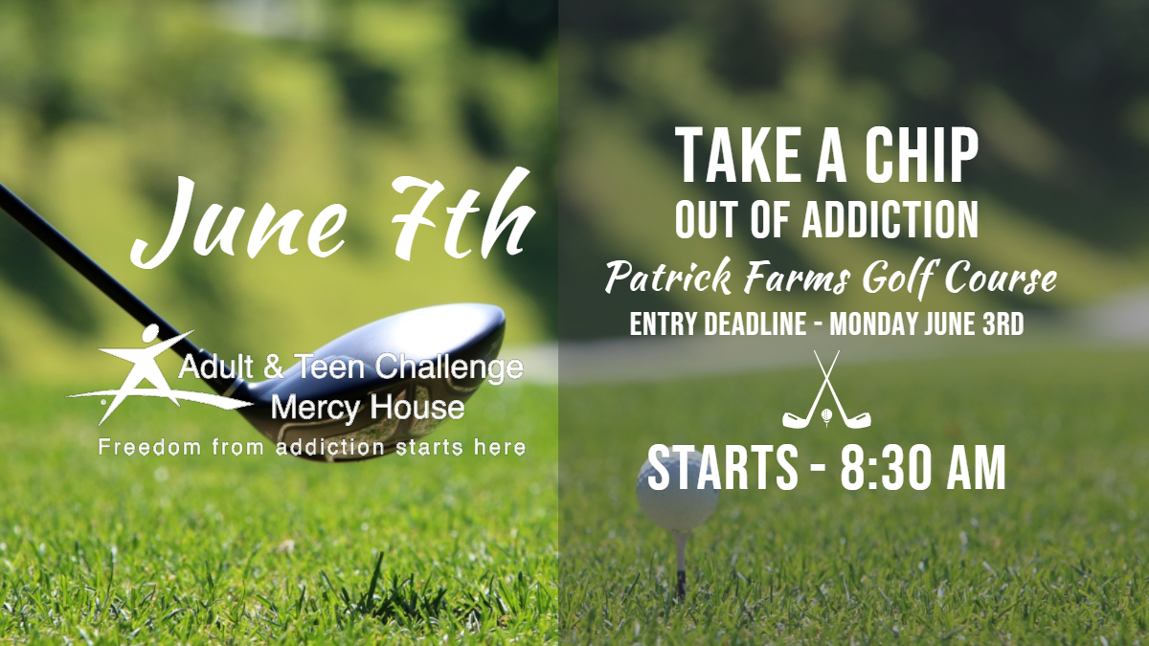



[Type a quote from the document or the summary of an interesting point. You can position the text box anywhere in the document. Use the Drawing Tools tab to change the formatting of the pull quote text box.]

*MC900358059[1]****presents* 5th Annual Mercy House ADULT & TEEN CHALLENGE Golf Tournament.**



**Located at: PATRICK FARMS Golf Course**

**Brandon, MS.**

**DATE: - Friday June 7th, 8:30am shotgun start**

**LUNCH: *Penn’s Seafood and Catering***

**CORPORATE SPONSORS**





**will be serving fish and chicken at 12.30pm**

“Thank you to all of you who support this ministry by sponsoring or

participating in the event. We appreciate you very much!”

**FORMAT: 4 MAN SCRAMBLE W/ MULLIGANS COST: $125 / PERSON**

**HOLE SPONSOR:** **$125.00**. Front nine **OR** back nine exposure

**DUAL HOLE SPONSOR: $250.00** **Both** front nine **AND** back nine exposure

**DOOR PRIZES:** Will be randomly drawn by those who participate.

**Team Name**:___________________________

Player #1 ___________________________ Phone # _____________________

Player #2 ___________________________ Phone # _____________________

Player #3 ___________________________ Phone # _____________________

Player #4 ___________________________ Phone # _____________________

**Mail Entries to: M.H.A.T.C. Golf Tournament, PO Box 266, Georgetown, MS. 39078**

**Fax:** **1**-**601-858-2420** **e-mail:** [**bhyde@mercyhouseatc.com**](mailto:bhyde@mercyhouseatc.com)

**Website Address:** [**www.mercyhouseatc.com**](http://www.mercyhouseatc.com)

**Contact:** **Barry Hyde at 601-622-0005 for further information.**